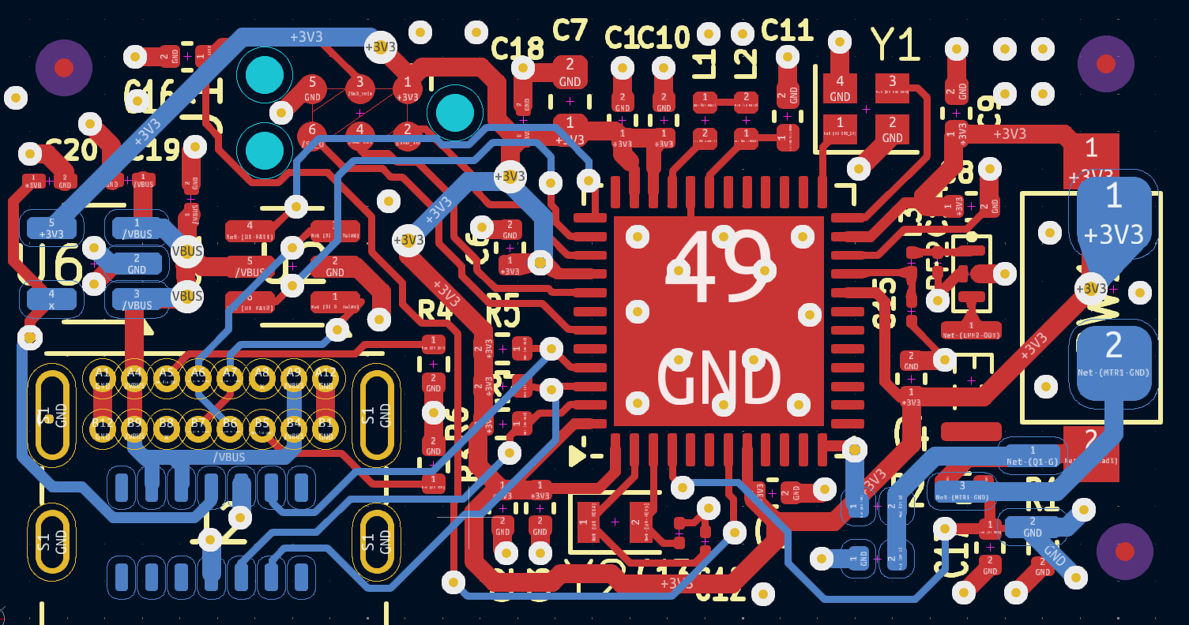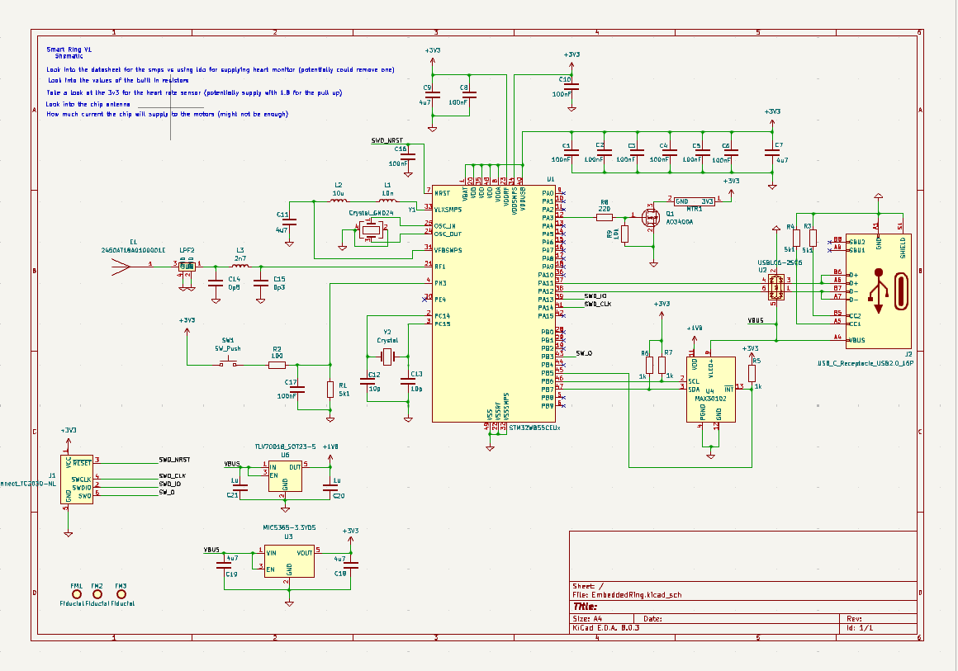

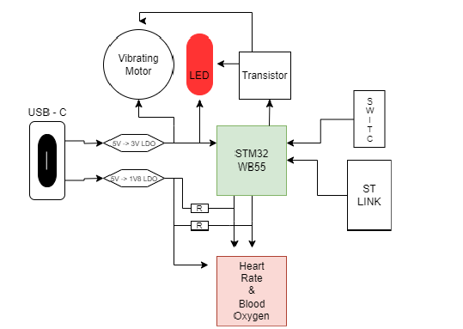

Milestone 1:

-We have received our PCB Board and the components and plan to solder together later this week.

-Due to the size of components we have contacted someone (Ryan Manwill) in the storeroom to help us use a heat oven and solder paste to build the board on Thursday.

-We received our DevBoard with the STM32WB55 chip, and discovered it didn’t work with our current VS code setup.

-We found a way to get it to run with STMcube, and will look into deciding if we can integrate this with VScode, or code entirely in STMcube.

-We are able to run code to make the LED on our dev board blink, so we know communication and internal clocks are working.

-We plan to add an LED in addition to the motor on the PCB so that we can also visually see when the users heart rate gets too high.

-We also discussed using UART to transmit and display Blood oxygen levels when connected VIA USB-C.

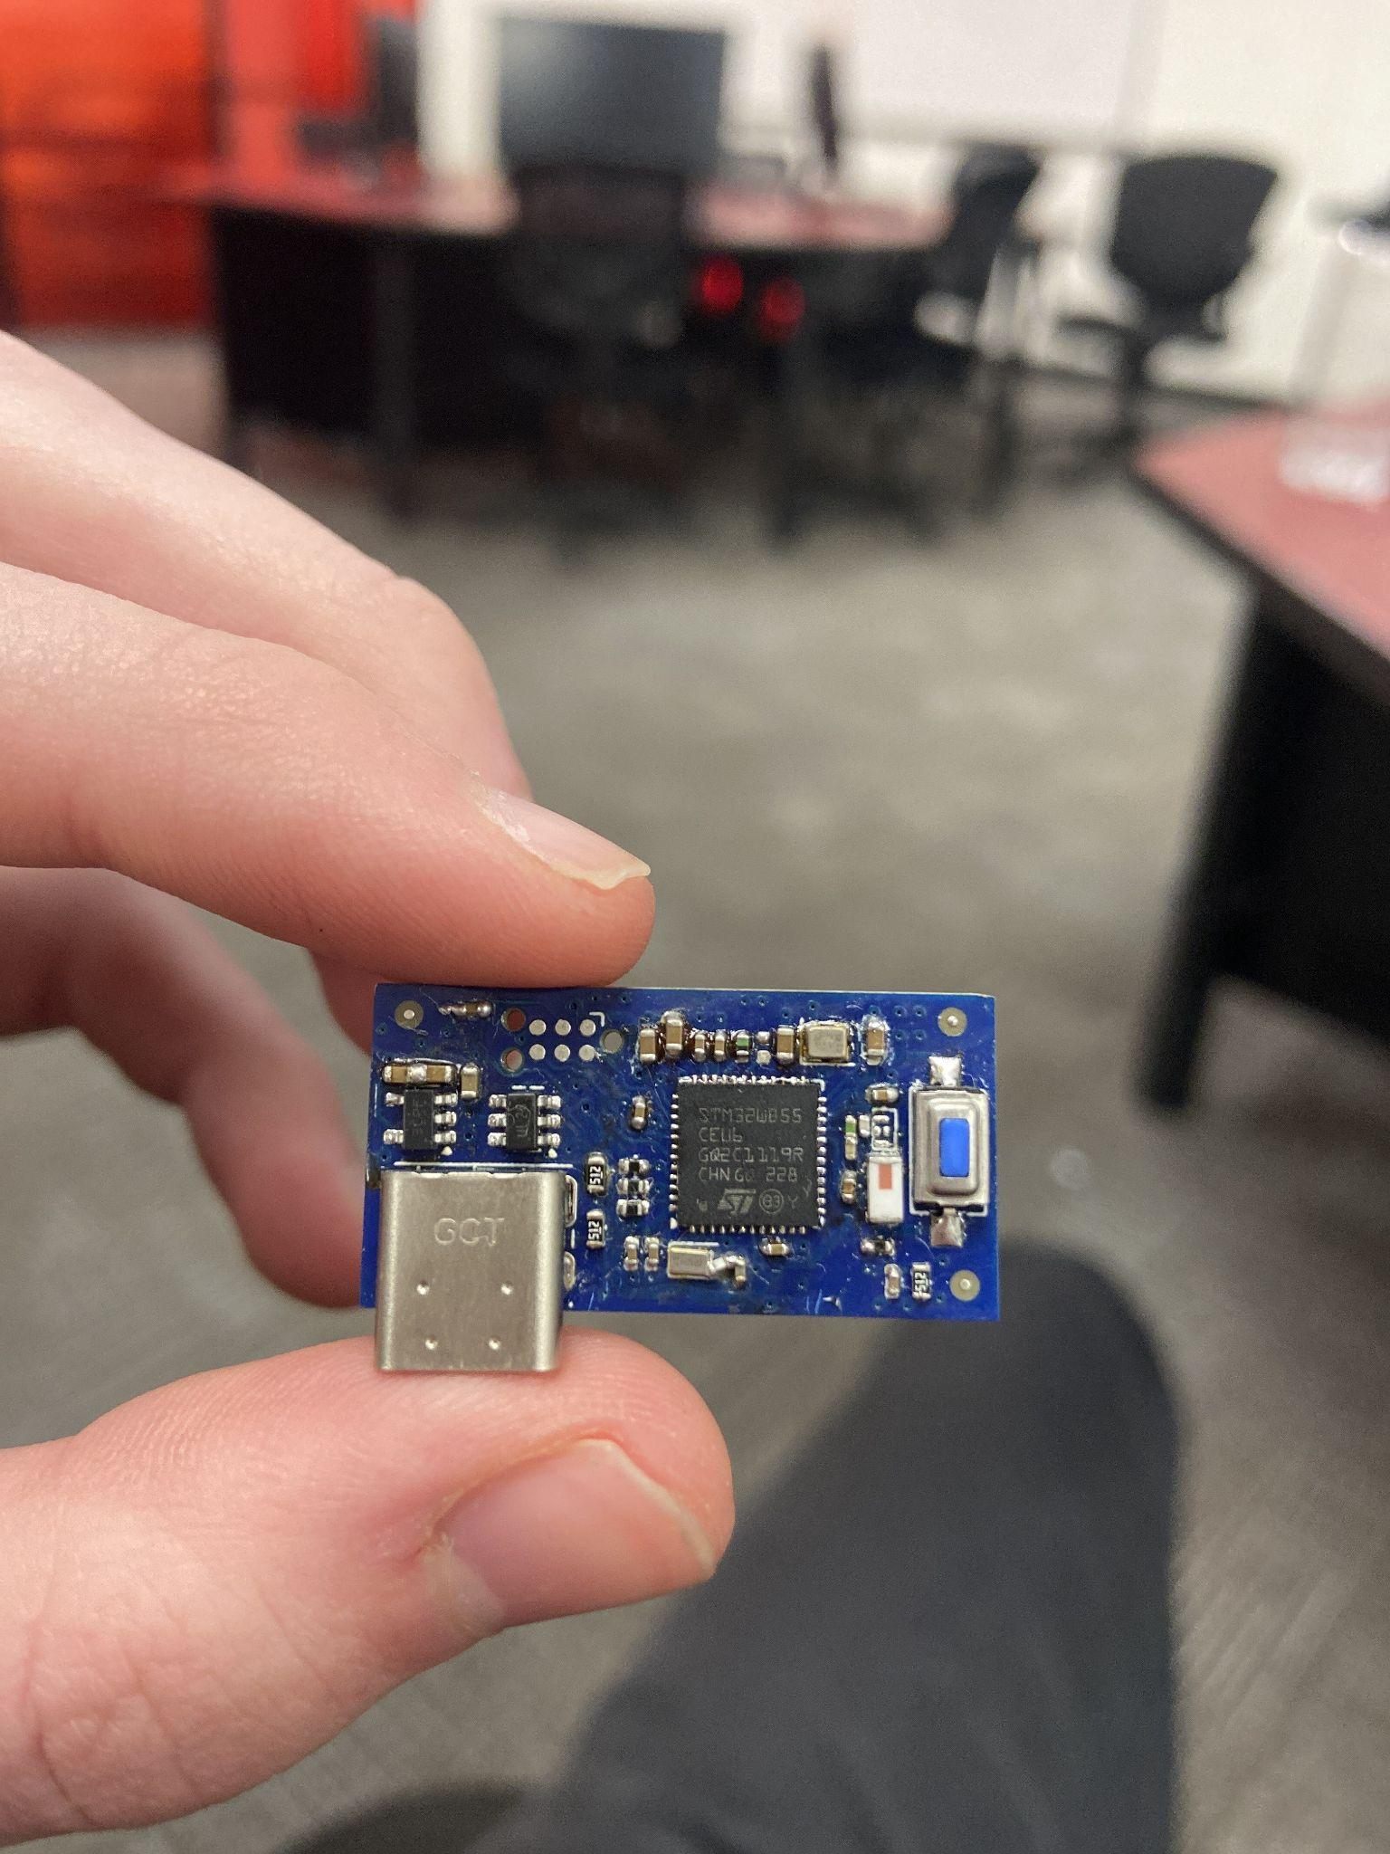

Additional Notes for milestone 1:

Milestone 2:

We met with Vincent for our second milestone meeting. In the meeting, we discussed our plans to initialize communication with our custom PCB soon. We originally were hoping to have comms with the PCB done, but were unable to accomplish this due to a short on the PCB and a missing programming cable. However, these issues have been resolved and we are working towards getting communication and implementing I2C functions to communicate with our on-board sensors.

Moving forward, we are working diligently to get our PCB brought up/flashed using an external ST-Link debugger. We also started designing a custom enclosure for our board. The enclosure resembles a watch, since our board measures heart rate and blood/oxygen content and needs to be on the user's wrist. We are also working on communicating with other I2C devices using our dev-board that has the same MCU as our PCB.

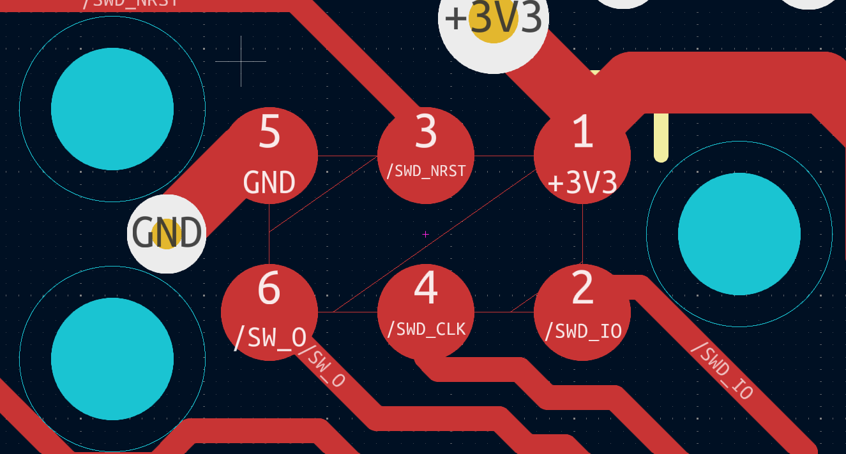

Additional Notes for milestone 2:

Milestone 3:

This week, our team met with Ashton to discuss our current progress and challenges related to our custom PCB. We explained that we were still unable to program the board using the ST-Link, as the device could not be detected. This led us to suspect that the board was either not receiving power or potentially damaged.

We reviewed several issues that arose during the assembly process. Specifically, our initial use of a reflow oven likely caused the microcontroller to float, resulting in poor pad connections. To address this, we reflowed the microcontroller using a heat gun, and the connections now appear solid upon visual inspection.

Another key issue we identified was a missing inductor that is required to power the chip in our configuration. In our meeting, we discussed switching the board to operate in “LDO mode,” which involved removing a capacitor and inductor and shorting the corresponding pads. Despite making these changes, the board still failed to power on.

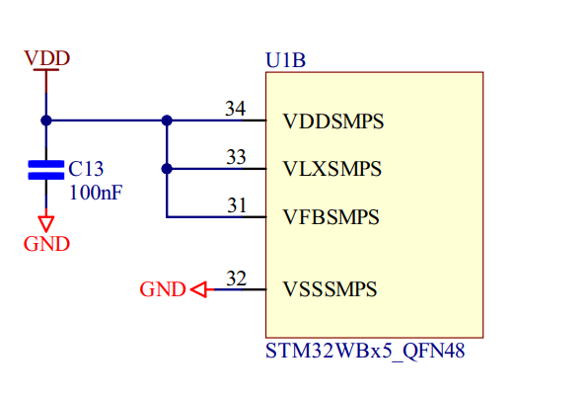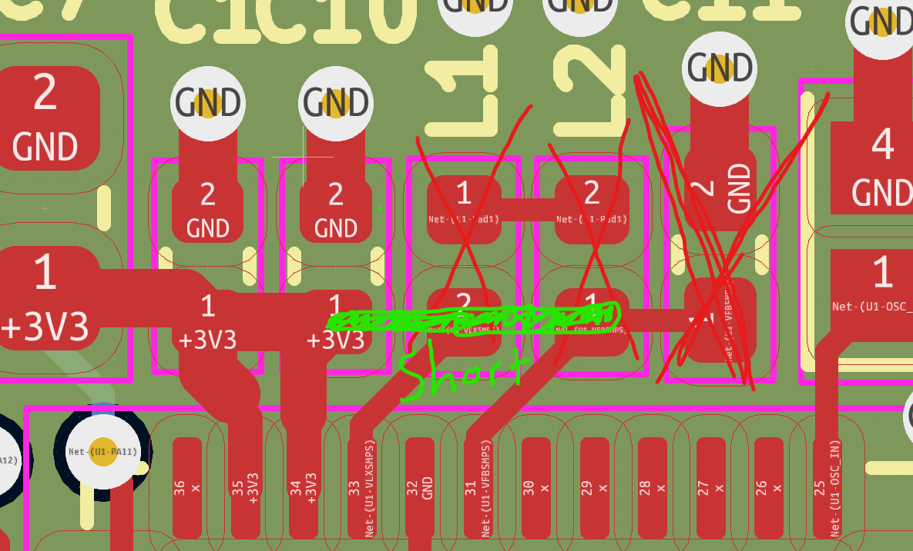

We verified all major connections, and visually everything appears to be in order. Ashton recommended we isolate the issue by removing all non-essential components that are not required for basic power and debugging. His suggestion was to systematically eliminate possible sources of shorts or faults by simplifying the board and reintroducing components one at a time.

We plan to follow this methodical approach in order to pinpoint the exact cause of the issue and get the board operational.

